**Lecture 4.**

**Functions and limits. Theorem (the limit of function is unique). Properties of the limits.**

**Definition of a function**. If to every value of a variable $x$, which belongs to some collection (set) $E$, there corresponds one and only one finite value of the quantity $y,$ then $y$ is said to be a *function* (single-valued) of $x$ or a *dependent variable* defined on the set $E$, $x$ is the argument or *independent variable*. The fact that $y$ is a function of $x$ is expressed in brief form by the notation $y=f\left(x\right).$

If to every value of $x$, belonging to some set E there corresponds one or several values of the variable $y,$ then $y$ is called a *multiple-valued function* of $x$ defined on $E.$ From now on we shall use the word “function” only in the meaning of a single-valued function, if not otherwise stated.

**The domain of a function.** The collection of values of $x$ for which the given function is defined is called the *domain* of this function. In the simplest cases, the domain of a function is either a closed interval $\left[a,b\right],$ which is the set of real numbers $x$ that satisfy the inequalities $a≤x≤b,$ or an open interval $\left(a,b\right),$ which is the set of real numbers $x$ that satisfy the inequalities $a<x<b.$ Also possible is a more complex structure of the domain of function.

**Inverse function.** If the equation $y=f(x)$ may be solved uniquely for the variable $x,$ that is, if there is a function x $=g(y)$ such that

$$y=f\left[g(y)\right],$$

then the function x $=g\left(y\right),$ or, in standard notation, $y=g\left(x\right),$ is the *inverse* of $y=f\left(x\right).$ Obviously, $g\left[f(x)\right]=x,$ that is the function $f\left(x\right)$ is *the inverse* of $g\left(x\right)$ (and vise versa).

In the general case, the equation $y=f(x)$ defines a multiple-valued inverse function $x=f^{-1}(y)$ such that $y=f\left[f^{-1}(y)\right]$ for all $y$ that are values of the function $f\left(x\right).$

**Composite and implicit functions.** A function $y$ of $x$ defined by a series of equalities $y=f\left(u\right),$ where u $=φ\left(x\right),$ etc., is called a *composite function.* A function defined by an equation not solved for the dependent

variable is called an *implicit function*. For example, $x^{3}+y^{3}=1$ defines $y$ as an implicit function of $x.$

**Limit of a function**

 , where  is a domain of the function and  is limit point of .

**Definition.** We say that ****, if  there exists a such that if $0<\left|x-a\right|<δ(ε)$ then $\left|f\left(x\right)-b\right|<ε.$ (Figure 1).

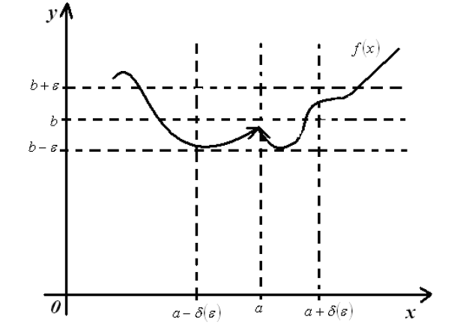

Figure 1.

**Definition 2. (**according to Cauchy, i.e., “ $ε-δ"$ definition of limit).

  ,   .

**Definition 3. (**according to Cauchy, i.e., “ $ε-δ"$ definition of limit).

  ,   .

**Definition $\hat{2}$. (** “neighborhood”definition of limit).

**    **

**Definition $\hat{3}$. (** “neighborhood”definition of limit).

**    **

**Properties of the limits:**

Let $a$ be a real number, and suppose that 

That is, the limits exist and have values respectively. Then:

1. 

( the limit of a sum is the sum of the limits).

1. 

( the limit of a difference is the difference of the limits).

1. 

( the limit of a product is the product of the limits).

1. 

provided  ( the limit of a quotient is the quotient of the limits, provided the limit of the denominator is not zero).

1. 

provided ****, if  is even. (the limit of an nth root is the nth root of the limits).

1. 

(A constant factor can be moved through a limit symbol).